
eProtocol SPA Form User Guide
Allina Hospitals & Clinics

August 2011

Table of Contents

GETTING STARTED IN ePROTOCOL 3
eProtocol General User Tips 3
User Agreement & Log-In 4
Create SPA Form 5
Create SPA Only Form - not linked to IRB Protocol 6
Create an IRB/SPA Form – Linked to an IRB Protocol 7
Clone SPA Form 8
Delete SPA Form 9

COMPLETING A NEW SPA FORM 10
SPA Form Design & Functionality 10
SPA Form Navigation 11
Personnel Information 12
Study Sites 15
General Checklist 16
ClinicalTrials.gov 17
Project Information 18
Section 1 - General Information 18
Section 2 - Medical Equipment, Investigational Devices 21
Section 3 - Drugs & Biological Products 24
Section 4 - Lab Pricing 29
Section 5 – Service & Pricing Information 34
Section 6 – Attachments 45
Certification 48
Study Administration 49
Check for Completeness 50
Submit Form 51
Print View 52
Return Notes 55

GETTING STARTED IN ePROTOCOL
Welcome to eProtocol, Allina’s Institutional Review Board (IRB) and Sponsored Projects Administration (SPA) electronic research submission system.

eProtocol General User Tips
Follow the tips outlined below when using the system.
  - Use a recommended browser.
eProtocol supports Microsoft Internet Explorer, Mozilla Firefox, and Apple’s Safari. We recommend Firefox for best results.

  - Allow pop-up windows.
eProtocol uses pop-up windows to open content areas, so be sure pop-up windows are allowed on the eProtocol site.

  - Avoid using your browser's BACK button.
Use the menus, links, and buttons within the application to navigate.

  - SAVE frequently.
eProtocol will time out after 45 minutes of inactivity.

  - Be patient.
Some processes can take a minute to run. Although data is loading, your browser may not indicate activity.

  - Read the Instructions.
Many pages in the application offer instructions on the page to guide you and to answer the most common questions. You can also check the FAQ page for answers to eProtocol questions.

  - Sign out.
To avoid login problems always Sign Out from within eProtocol. For added security, it is recommended to shut down your browser completely when you are finished using eProtocol.

User Agreement & Log-In
- If you do not have a user ID and password, you will not be able to access the eProtocol System until the user agreement is submitted to Allina Research Administration. The Allina eProtocol User Agreement is available on Allina’s Research Administration eProtocol web page.
Read and sign the user agreement; then submit it to Allina Research Administration. Upon receipt of your signed user agreement, you will receive an email from ‘allina-noreply@keyusa.com’ with your user ID and password.
- Log into eProtocol.
  - You will be required to change your password the first time you access the system.
  - Your home page will then appear.
  - To enter your SPA home page, click on the SPA tab as pictured below.
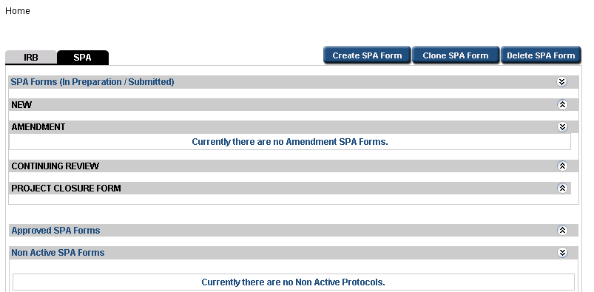

Create SPA Form
- Click the “Create SPA Form” button.
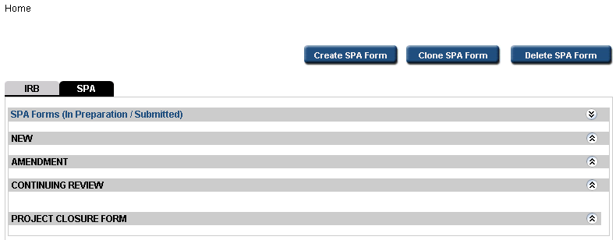
- Select the check box next to SPA, if the box is not already checked. Next, click the circle to the left of “SPA Form” to create the SPA Form. (If you are submitting to both the Allina IRB and SPA, you must start in the IRB side first and with the Allina IRB Guide before starting the SPA form.)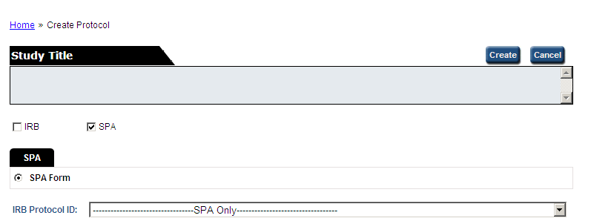

- SPA projects fit into two categories for form submission (choose one):
  - SPA Only Form - not linked to an IRB Protocol is a project only being submitted to SPA.
  - IRB/SPA Form - linked to an existing IRB Protocol is a project that must also go through an Allina IRB.

Create SPA Only Form - not linked to IRB Protocol
Continue to follow the instructions below if you do not link to an IRB Protocol; otherwise skip to the next section.
- Enter Study Title
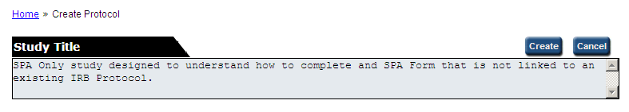
- Click “Create” button
The newly created SPA Form will open in a new window.
Continue to Completing a New SPA Form section.

Create an IRB/SPA Form – Linked to an IRB Protocol
Continue to follow the instructions below if the study will be submitted to an Allina IRB.
The IRB Protocol must be created on the IRB section of eProtocol before it can be linked to SPA. In addition, the user creating the SPA Form must be assigned to the study in IRB Form as either the Principal Investigator, a Study Coordinator, or as Sponsored Projects Administration (SPA) Contact.
- From the IRB Protocol ID drop down, select the IRB Protocol that the SPA Form will link to.
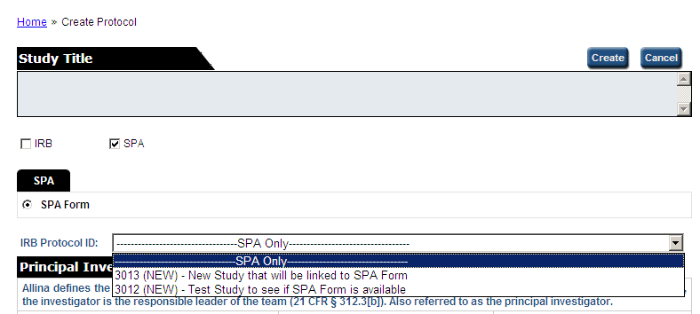
- Click “Create” button
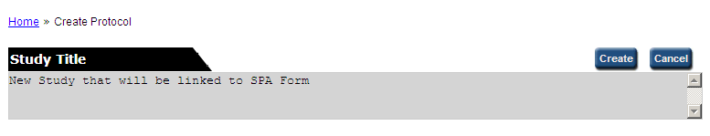
The newly created SPA Form will open in a new window.
Continue to Completing a New SPA Form section.

Clone SPA Form
A Cloned SPA Form will copy all information for the SPA Form selected and create a new draft SPA Form. The researcher must make changes as necessary to the cloned form prior to submission to SPA.

If your SPA Form is not linked to an IRB Protocol, you may Clone the SPA Form. If your study is linked to an IRB Protocol, do not clone your SPA Form.
Follow the instructions below to Clone an SPA Form:
- From the Investigator Home Page in SPA module, select the Clone SPA Form button.

- Select the radio button next to the SPA Form to be cloned.

- Click Clone SPA Form button.
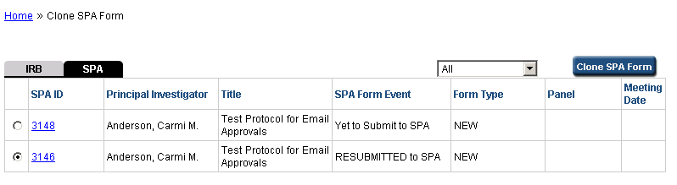
2
3

A draft form identical to the cloned form is now available for editing.

Please ensure all necessary edits are made to the new form before submission.

Delete SPA Form

A SPA Form that has not yet been approved by SPA can be deleted from eProtocol. If it has already been submitted to SPA, it must be returned by SPA manager in order to delete.
Follow the instructions to Delete SPA Form:
- From the Investigator Home Page in SPA module, select the Delete SPA Form button.

- Select the check box next to the SPA Form to be deleted.

- Click Delete SPA Form button.

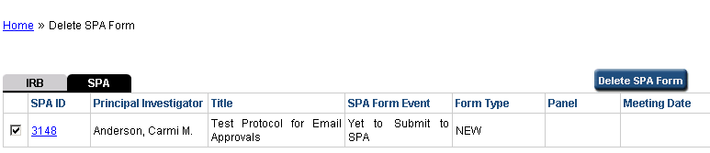
2
3

COMPLETING A NEW SPA FORM

SPA Form Design & Functionality
The SPA Form has the following sections to complete for SPA review.
- Personnel Information
- Study Sites
- General Checklist
- Project Information
  - General Information
  - Medical Equipment, Investigational Devices
  - Lab Pricing
  - Services & Pricing Information
  - Attachments
- Certification
Note: The Study Administration section will be completed by SPA and is informational only.
In addition, eProtocol has several features that assist the researcher in completing the submission and receiving approval for the study.
- Check for Completeness: Identifies the sections that must be completed before the protocol can be submitted.
- Submit Form: Electronically sends the protocol to SPA Manager for review.
- Print View: Enables the user to print a hard copy of the complete SPA Form or specified sections.
- Event History: Lists the actions that have occurred since the SPA form was created.
- Return Notes: If SPA form is returned to Investigator for additional information prior to approval, notes are entered here by SPA Manager.

SPA Form Navigation
The eProtocol System has tools and shortcuts to help navigate through the System.
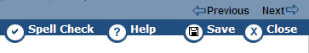
Figure: Form Navigation (top hand menu)
- Click Spell Check to spell check the entries.
- Click the Previous or Next icon to go to the previous or next page.
Moving to the Previous or Next page, will automatically save changes.
- Click Close to close the SPA Form.
- Click Save to save the SPA Form.
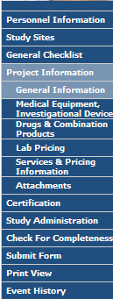
Figure: SPA Form Navigation Links (left-hand menu)
Click the Navigation Links on the blue bar on the left side of the screen to jump to the section you wish to complete at any time. For the first SPA Form, it is recommended going through each section in order (top to bottom) to complete the form.

Personnel Information
The Personnel Information section is the first to display when a new protocol is created or an existing protocol is opened. Enter information regarding the personnel who will be working on the study. The Principal Investigator is mandatory. Study Coordinator(s) and SPA Contact may be added if they apply to the study. All users entered here will have edit access to the study.
If the SPA form is linked to an IRB protocol, changes to the Personnel Information section must be made within the IRB section of eProtocol.
Follow the steps below to add Personnel Information to the form:
Step 1
The Principal Investigator (PI) field auto-populates with the name of the user who created the protocol. This can be changed by clicking the binocular icon beside the name field. The Find User pop-up will display. Search for, select and add the user who will serve as the principal investigator.
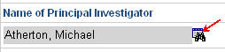
Figure: Name of Principal Investigator text box and find icon
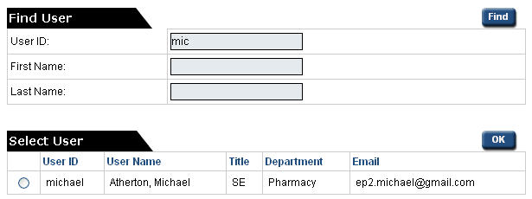
Figure: Find User pop-up
Step 2 (optional)
Enter any demographic details that do not display.
Step 3
For Study Coordinator(s), click Add button.
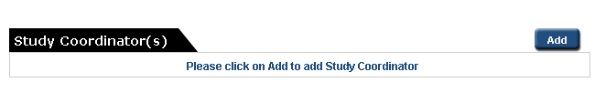The Study Coordinator pop-up will be displayed.
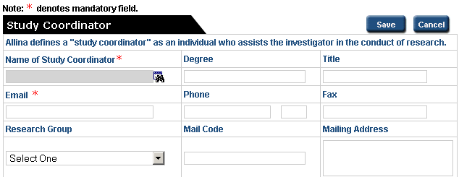
Step 4
Follow steps 1 and 2 to enter details for Study Coordinator, and click Save.
Note:
- A person must have a user id and password to be added to the study.
- To delete a user listed as “Study Coordinator,” select the record and click Delete.
Step 5
Add Sponsored Projects Administration Contact. This is the primary contact for SPA billing questions. This field can be left blank if your site does not have a specific person for billing.
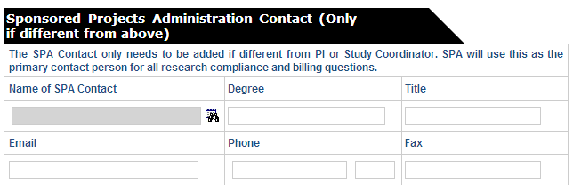
Note:
Clicking the Next arrow at the top or bottom of the screen will save the information and move to the next section of the form.

Study Sites
Select the Allina site(s) where the study items and/or services will be used.
If the SPA Form is linked to an IRB Protocol, this section is ‘Read Only’ and changes must be made within the IRB Protocol form.
To complete the Study Sites section:
- You must select at least one Study Site to proceed to the next section.
- If a text field appears beside your selection, (e.g., Allina Medical Clinic) enter the specific name(s) of the clinic or facility separated by commas.
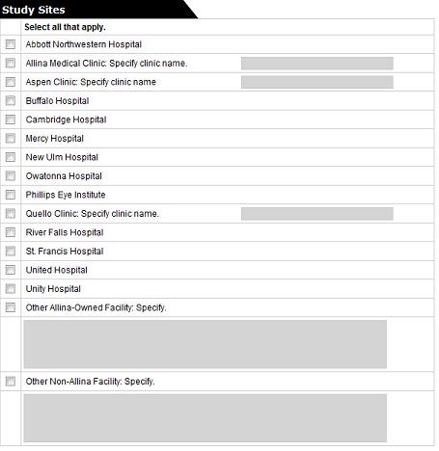
Figure: Study Sites section

General Checklist
The purpose of the General Checklist is to determine the requirements of the study. Checking certain items may require additional information in the SPA form.
To complete the General Checklist:
- Check the box next to each statement that is true of the study.
- You must select at least one checklist option to proceed to the next section.
If the SPA Form is linked to an IRB Protocol, the General Checklist contains six items from the IRB Protocol form that are ‘Read Only’ and can only be changed in the IRB Protocol form.
The items in bold text are related to the SPA Form. Please review and select any of the SPA items that apply.

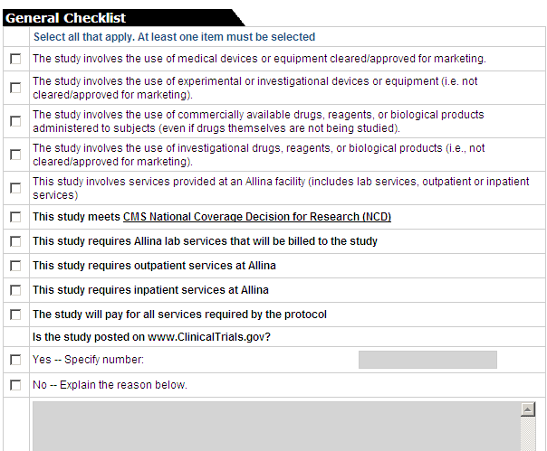
Figure: SPA General Checklist section

ClinicalTrials.gov

“Clinicaltrials.gov is a registry of federally and privately supported clinical trials” and is operated by the National Institutes of Health (NIH).

Is the study posted on www.ClinicalTrials.gov?
- Check ‘Yes’ or ‘No’
- Enter the ClinicalTrials.gov number or the reason the study has not been posted.

The ClinicalTrials.gov # is an eight digit number preceded by letters ‘NCT’. Only enter the eight numeric digits.

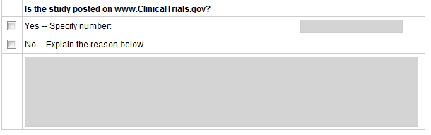

Project Information
The Project Information section consists of several sub-sections where the researcher must provide information regarding the research study. Each sub-section is explained below.

Section 1 - General Information
If the SPA Form is linked to an IRB Protocol, several fields are ‘Read Only’ and may only be changed in the IRB Protocol form. These fields appear in gray.
Protocol Title – the title of the study entered in Create Protocol page is displayed. The project title may be modified in this section if necessary.
Protocol Short Title – Enter an abbreviated name or acronym for the study if one exists.
Study Start Date – Enter the Start Date indicated on IRB application
Study End Date – Enter the End Date indicated on IRB application
Enter Start and End Date by keying in ‘mm/dd/yyyy’ format or click the calendar icon next to the text box to select a date from the Calendar pop-up.
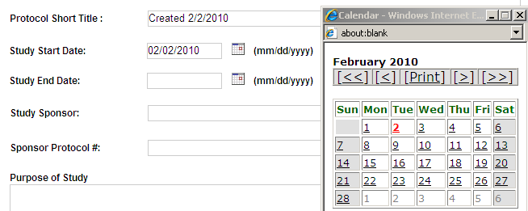

Study Sponsor – Enter name of entity sponsoring the protocol. If no sponsor, enter ‘None’.
Sponsor Protocol # – Enter number assigned by sponsor to the protocol. This must be the sponsor’s number. Enter N/A as appropriate.
Purpose of Study – Enter summary of the purpose of your study. Include what you hope to learn from the study. This information can be copied from the Informed Consent.
Background - Enter relevant background information on condition, procedure, product, etc.

Enrollment Questions
How many subjects do you plan to enroll (i.e., your enrollment goal)? NOTE: You must receive IRB approval before increasing enrollment in the study. - Enter the number of subjects indicated on IRB application
If this is a multi-center study, what is the total number of subjects to be enrolled from all centers? - Enter the number indicated on IRB application.

Digital Radiologic Image Question
Does your study require special handling of digital radiologic images?
- If your study requires Allina to perform any special handling of digital radiologic images, specify here by clicking ‘Yes, it does’.
- If ‘Yes, it does’ is checked, select one of the options below for the best description of the request. You will be contacted by Allina Information Services to discuss your request.
- De-identification for secure transmission – Images sent outside of Allina must either be sent HIPAA secure or de-identified in order to meet HIPAA guidelines.
- Storage in study-specific folder – The service being requested is stored digitally and Allina may need to have a copy available for later use.
- Other (i.e., any population that is not specified above) – please describe security measures in text box available.

Research Plan Code – Enter one to three digit research plan code as assigned by SPA for your research site. If you do not have a Research Plan Code contact SPA.
Allina Department Question for Device Studies
In what Allina Department will the main research intervention (i.e. procedure(s)) take place? - This question is required for device studies only.
If applicable, select the Allina hospital department from the drop down where the main research intervention (procedure) will take place. This will be used for billing compliance purposes.
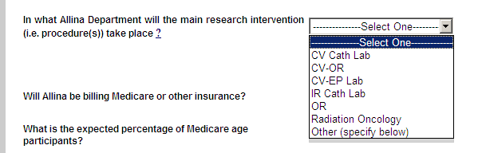
Figure: Allina Department drop-down
- CV Cath Lab – aka.. CV/EP Lab, Cardiovascualr, Cath Lab
- CV-OR – Cardiovascular OR
- IR Cath Lab – Interventional Radiology
- OR – Operating Room
- Radiation Oncology
- If department is not listed, select ‘Other (specify below)’ to enter another department in the text box below drop-down.

Billing Insurance Questions
Will Allina be billing Medicare or other insurance? – If the study intends to bill routine costs of care included on the Schedule of Events, select ‘Yes’. If the study is paying for all services included on Schedule of Events, select ‘No’.
What is the expected percentage of Medicare age participants? – If the study will involve participants of Medicare age, enter an estimate for SPA to calculate cost/reimbursement information.

Section 2 - Medical Equipment, Investigational Devices
For studies linked to IRB Protocol, this page is “Read Only” and edits must be made on the IRB Protocol form.

To complete the Medical Device section:
Step 1 - Click Add. Add Investigational Device pop-up is displayed.
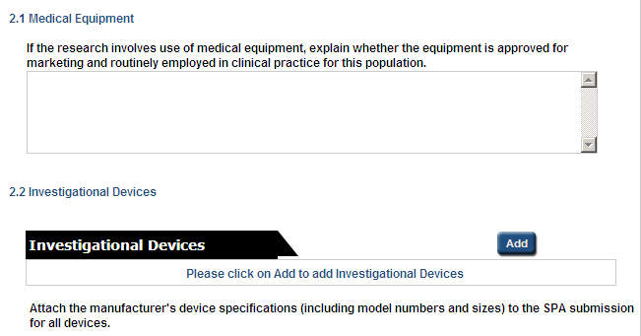
1

Figure: Medical Equipment, Investigational Devices section

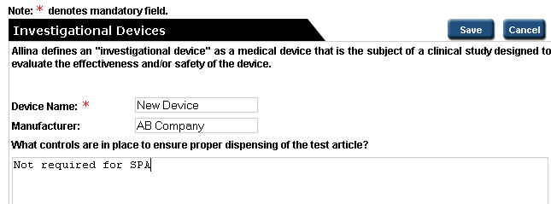
2
Figure: Add Investigational Device pop-up
Step 2 - Enter Device Name and Manufacturer.
Step 3 – Select Regulatory Status option. Only one option is available for each device. Depending on the option selected, additional fields will open for completion.
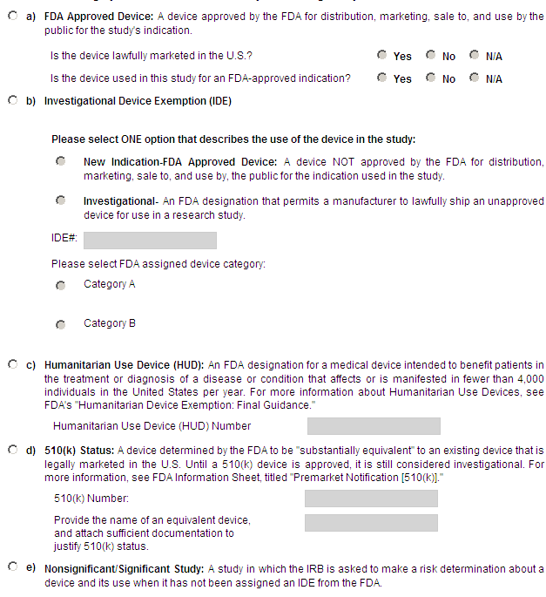
Step 4 – Complete SPA Information questions a) through c). Enter N/A where appropriate.
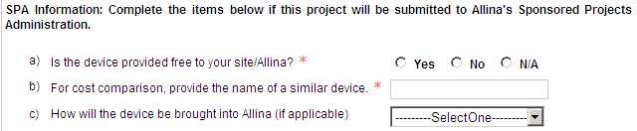

Step 5 - Click Save. The pop-up closes, and the record is added to the Protocol Information page.

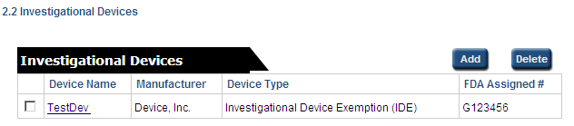
Figure: Investigational Device added to table

Notes:
- Additional study devices may be added as necessary by repeating Steps 1-5
- To delete an Investigational Device record, select the record and click Delete.
- Click on Device Name link to view/edit the record.

Section 3 - Drugs & Biological Products
This section is required for any investigational or commercial drugs, reagents or biological products that are to be administered to subjects during the study, depending on the criteria discussed below.

- For studies linked to IRB Protocol, this page is “Read Only” and edits must be made on the IRB Protocol form.

- If completing SPA Only form and the project meets Allina Vendor Criteria, the Drug & Biological form does not require completion. The drug information is not required since Allina will not be billing any study related services to a third party payer.

- If you project does not meet the Allina Vendor Criteria, you will need to follow the instructions below on completing this form.

To Complete Section 3 – Drugs & Biological Products:

Step 1 – Answer questions 1) and 2) shown below. Enter N/A where appropriate.

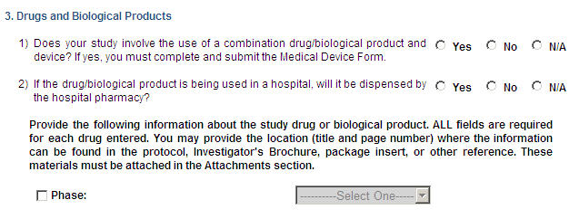
1
2
Figure: Drugs or Biological Products top of page
Step 2 – Select Phase: checkbox

Step 3 - Select appropriate phase of the drug study from the drop down menu.

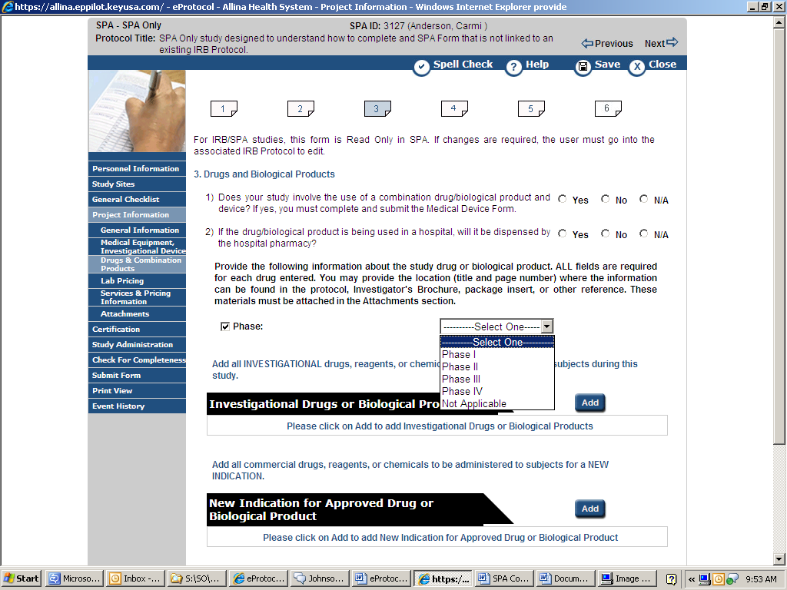
3

Figure: Phase drop down menu

Step 4 – Determine which drug tables require entry for your study and complete using the instructions for each on the following pages. The three drug tables are show below.
Add buttons for each drug table are displayed if related checkbox is selected in General Checklist section.
If the appropriate table does not have an Add button, return to the General Checklist and select either of the drug related statements that is true for the study.
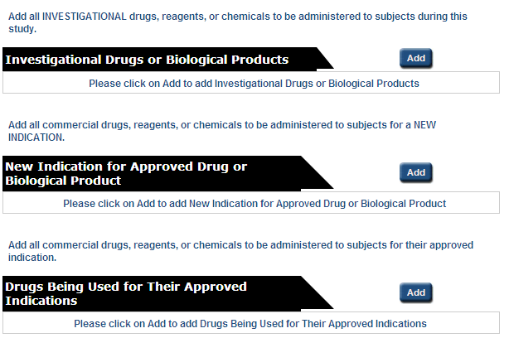
Figure: Drug Tables
Adding Investigational Drugs or Biological Products
Follow the steps below to add Investigational Drugs or Biological Products.
Step 1 - Click Add. Add Investigational Drugs or Biological Products pop-up is displayed.
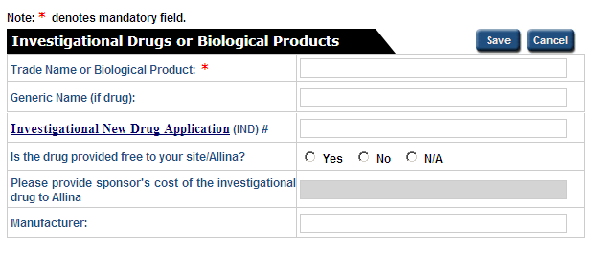
Figure: Add Investigational Drugs or Biological Products pop-up
Step 2 - Enter ‘Trade Name or Biological Product’ and other details as applicable.
Step 3 - Click Save. (The pop-up will close and the record is added to the Protocol Information page.)
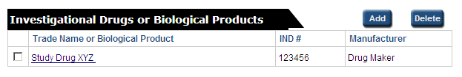
Figure: Investigational Drugs or Biological Products added to table
Note:
- Additional investigational drugs may be added as necessary by repeating Steps 1-3
- To delete a drug record, select the checkbox next to the item you want to delete and click Delete.
- Click on “Trade Name or Biological Product” link to view/edit the record.
Adding New Indication for Approved Drug or Biological Product
Follow the steps given below to add all drugs being used to obtain a New Indication for Approved Drug or Biological Product
Step 1 - Click Add. Add New Indication for Approved Drug or Biological Product pop-up is displayed.
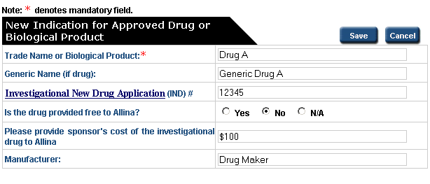
Figure: Add New Indication for Approved Drug or Biological Product pop-up
Step 2 – Enter ‘Trade Name or Biological Product’ and other details as applicable.
Step 3 - Click Save. (The pop-up will close and the record is added to the Protocol Information page.)
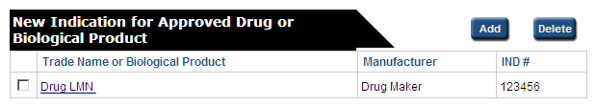
Figure: New Indication for Approved Drug or Biological Product added to table
Note:
- Additional new indication drugs may be added as necessary by repeating Steps 1-3
- To delete a drug record, select the checkbox next to the item you want to delete and click Delete.
- Click on “New Indication for Approved Drug or Biological Product” link to view/edit the record.
Adding Drugs Being Used for Their Approved Indication
Follow the steps given below to add all drugs being used for their approved indication within the study.
Step 1 - Click Add. Drugs Being Used for Their Approved Indication pop-up is displayed.
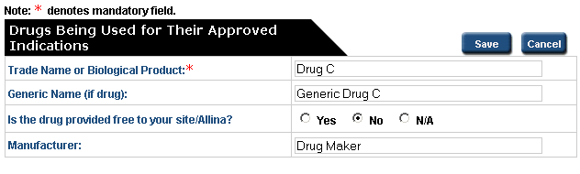
Figure: Add Drugs Being Used for Their Approved Indication
Step 2 – Enter ‘Trade Name or Biological Product’ and other details as applicable.
Step 3 - Click Save. (The pop-up will close and the record is added to the Protocol Information page.)
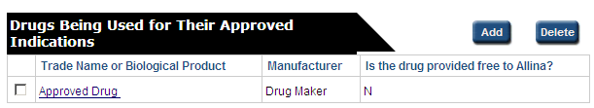
Figure: Drugs Being Used for Their Approved Indication added to table
Note:
- Additional approved drugs may be added as necessary by repeating Steps 1-3
- To delete a drug record, select the checkbox next to the item you want to delete and click Delete.
- Click on “New Indication for Approved Drug or Biological Product” link to view/edit the record.
Click the button at the bottom or top of the form to continue.

Section 4 - Lab Pricing
This section must be completed if the study requires lab services within Allina that are paid by the study. Projects will need to have a lab requirements document uploaded in the Attachment Section 6, so the Allina Lab can evaluate the services required.
Follow the steps below to add lab services to be billed to the study:
Step 1 - Click Add button. Add Lab Pricing pop-up is displayed.
If you do not see the Add button, return to the General Checklist and check “This study requires Allina lab services that will be billed to the study”.
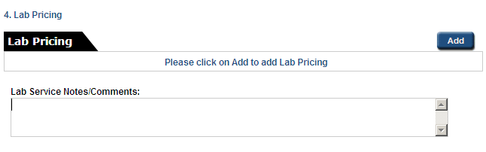
Figure: Lab Pricing section
Step 2 – Select Get Lab Price button. Lab Pricing Search window is displayed (below).
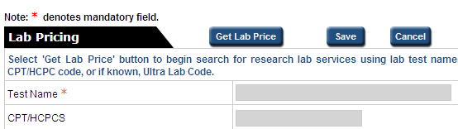
Figure: Lab Pricing pop-up
Step 3 – Find and Select appropriate lab test or procedure:
Option 1: Find using search fields
- Enter a portion of the Test Name, the CPT/HCPCS or Ultra Lab Code in the appropriate text box.

- Click Find button.

- Select the radio button next to the most appropriate test.

- Click OK button to accept the test

Note: To retry the search using a new data string click Cancel button. Repeat steps a. through d.

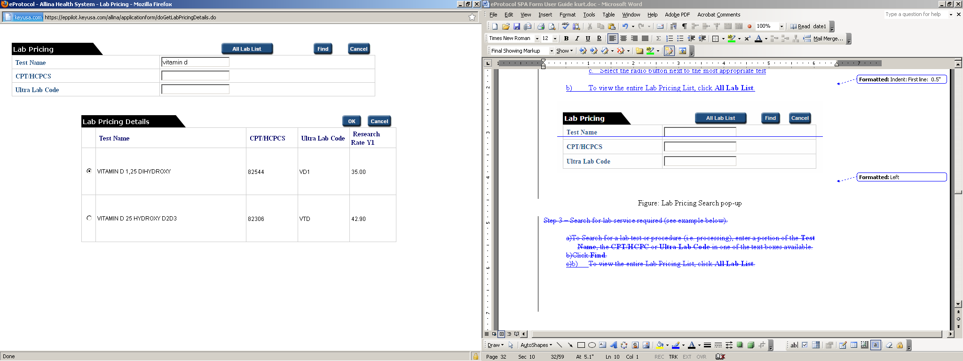
c.
a.
b.
d.
Figure: Lab Pricing Search
Step 3 – Find and Select (Option 2)
Option 2: Find from All Lab List
- To view the entire Lab Pricing List, click All Lab List button.

- Use right hand scroll bar to move up and down the list.

- Select the radio button next to the most appropriate test.

- Click OK to accept the test.
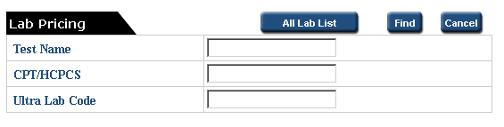
a.
d.
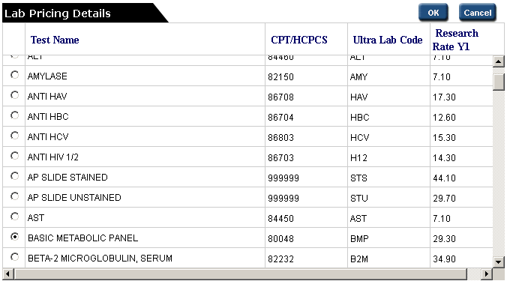
c.
b.
Figure: All Lab List View
Note: In Lab Pricing Details (search return table), user may click on the headers to sort by Test name, CPT/HCPCS, Ultra Lab Code or Research Rate.
Lab service information will be displayed on Lab Pricing window as Read Only.
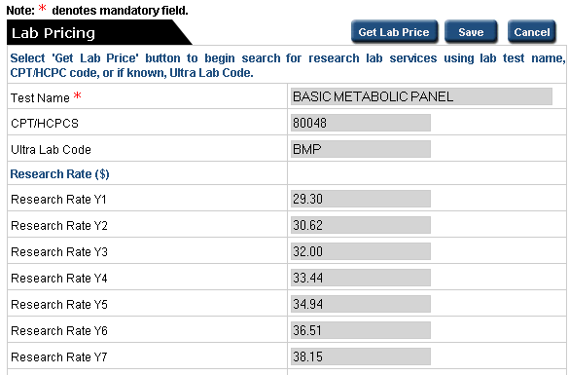
Figure: Add Lab Pricing window with lab service added
Step 4 – Enter # of Lab Services per participant (for the test selected) that will be conducted over the the length of the study in the Lab Pricing window.
Figure: Example of # of Service/participant added

Step 5 - Click Save button.

The pop-up will close and the lab test will be added to the Lab Pricing page.
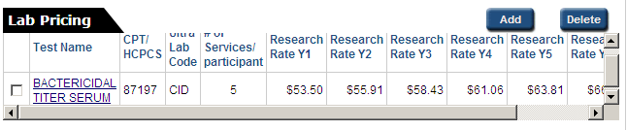Figure: Lab Service added to table
Lab Pricing Table displays the Test Name, CPT/HCPC, Ultra Lab Code, # of Services/parcipant and the lab service Research Rate Y1 (Year 1) through Y7 (Year 7).
Research Rate:
- Research Rate Y1 is the rate for the year the study was approved in SPA.
- Research Rate Y2 through Y7 begins at the new calandar year (January 1).
Step 6 – Enter any additional Lab Service Notes/Comments in text box on Lab Pricing page
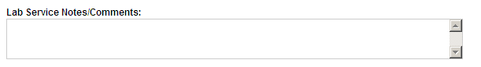
Figure: Lab Service Notes/Comments area
Please Note: The lab prices quoted in the Lab Pricing Section for Y2 through Y7 are estimates to the actual rate billed by the Allina Lab.

If research lab services are billed through Allina's hospital billing system (Excellian), the lab rates quoted in the eProtocol Lab Pricing Table should be used as the actual rates when completing research visit charge review paperwork sent by SPA.
Note:
- To add additional lab services required by the study, repeat Steps 1 – 5 for each service.
- To delete a lab service, check the box next to the lab service you want to delete and and click Delete.
- Click on “Test Name” link to view/edit the record.

Section 5 – Service & Pricing Information
This section must be completed if the study is paying for outpatient or inpatient protocol induced costs services.
5.1 Outpatient Services
To add outpatient service information, “This study requires outpatient services at Allina” must be checked in the General Checklist.

Outpatient services are all services except an overnight stay including all procedures. The term Outpatient is usually related to a research intervention that would not require an overnight stay or involve patients expected to stay overnight in the hospital.
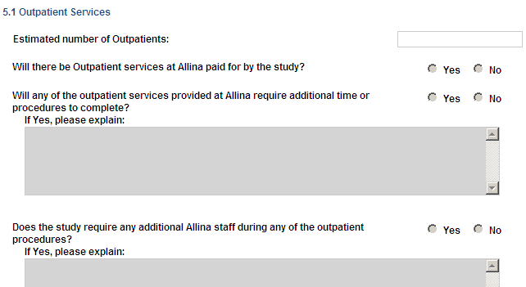
Figure: Outpatient Services section
Estimated number of Outpatients - Enter the estimated number of participants you expect to enroll or use Allina services. Once this field is completed, the remaining outpatient questions will open.
Will there be Outpatient services at Allina paid by the study – Select Yes or No. Select ‘Yes’ if the study will be paying for any item or service. Otherwise, check ‘No’. For instructions about the proper classification of services, please consult the Allina Billing Guide, Section IV, page 11.

Will any of the outpatient services provided at Allina require additional time or procedures to complete – If ‘Yes’ is checked provide an explanation in the text box below including the estimated additional time it will take to complete the service. Otherwise, check ‘No’.

Does the study require any additional Allina staff during any of the outpatient procedures - If ‘Yes’ is checked provide an explanation about the additional time for the outpatient procedure in the text box below. Otherwise, check ‘No’.

  - Inpatient Services
To add inpatient service information, “This study requires inpatient services at Allina” must be checked in the General Checklist.
Generally, an inpatient stay is any overnight stay in the facility and a room charge is generated. Complete this section if the study procedures will require an inpatient stay.
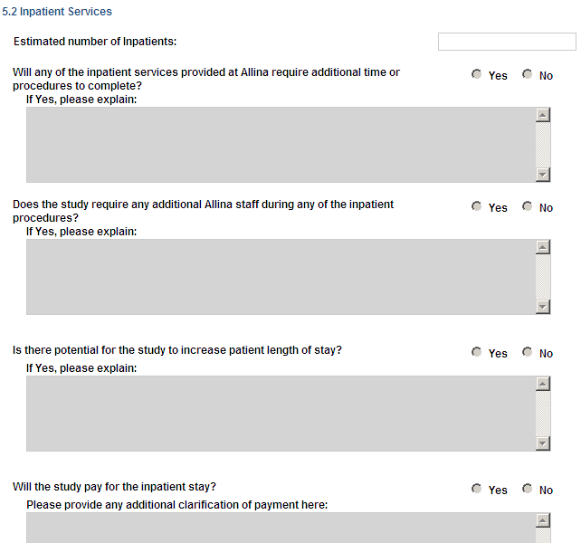
Figure: Inpatient Services section

Estimated number of Inpatients - Enter the estimated number of patients enrolled that will be classified as Inpatient(s) at Allina. Once this field is completed, the remaining inpatient questions will open.
Will any of the inpatient services provided at Allina require additional time or procedures to complete? – Check ‘Yes’ if this question applies and provide an explanation in the text box below including the estimated additional time or services it will take to complete the service. Otherwise, check ‘No’.

In an inpatient setting, additional procedures increase costs, but may not increase reimbursement, so it is important that additional time and procedures be clearly identified. SPA understands inpatient stays are ever changing, but planned services should be described.

Does the study require any additional Allina staff during any of the inpatient procedures? – Check ‘Yes’ if this question applies and provide an explanation in the text box below including the estimated additional services the staff will be providing. Otherwise, check ‘No’.

Is there potential for the study to increase patient length of stay? – Check ‘Yes’ if this question applies and provide an explanation in the text box below including the estimated increase to the length of stay. Otherwise, check ‘No’.

Will the study pay for the inpatient stay? – Check ‘Yes’ if this question applies and provide the details regarding the procedure in the box provided. Otherwise, check ‘No’.

Service Pricing Tables

Outpatient and inpatient protocol induced (directed) items and services required by the study must be listed in the appropriate Service Pricing table. There are three tables (shown below) depending the type of service.

Follow the steps below to complete the service pricing tables:
Step 1 - Click Add. Add Service Pricing pop-up is displayed.
The Service Pricing table should be used for technical services that may have a Current Procedural Terminology (CPT) code (e.g., 72160). If a service is not listed within the Service Pricing table, you may need to contact SPA or enter the information in the Other Services table (described later).
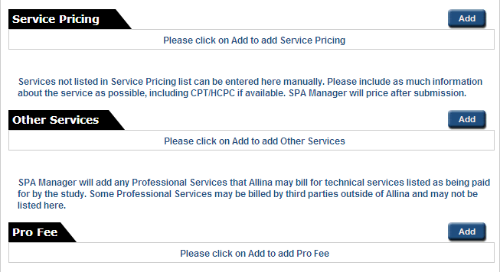
Figure: Service Pricing Tables

Step 2 – Click Get Service Price button. Service Pricing Search window is displayed.
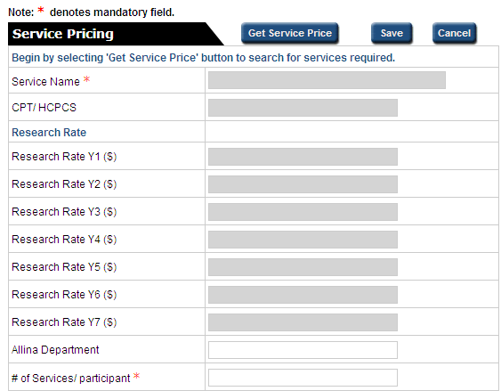
Figure: Service Pricing pop-up
Step 3 – Find and Select appropriate test or procedure:
- Enter a portion of the Service Name or the CPT/HCPCS in the appropriate text box (see example below for ‘mri’).

- Click Find button.

- Select the radio button next to the most appropriate test.

- Click OK button to accept the test

Note: To retry the search using a new data string click Cancel button. Repeat steps a. through d.
b.
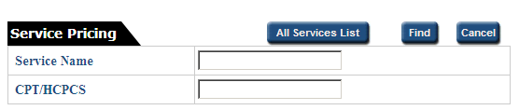
a.
Figure: Service Pricing Search pop-up

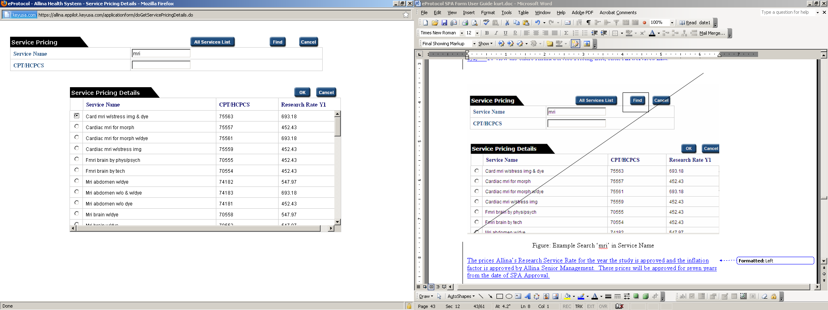
c.
d.
Figure: Example Search ‘mri’ in Service Name

Note:
- In Service Pricing Details (search return table), user may click on the headers to sort by Service Name, CPT/HCPCS, or Research Rate Y1.
- To search using new data, click Cancel.

Optional - Enter Allina Department where service is taking place
Step 5 – Enter # of Services per participant – enter the total number of services each participant will receive over the course of the study.
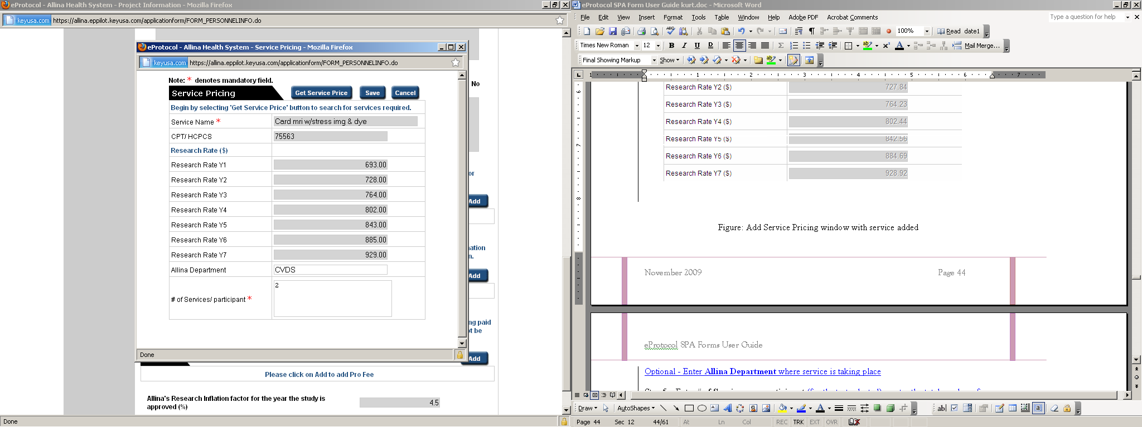
Figure: Add Service Pricing window with service added

Step 6 - Click Save. The pop-up will close, and the record will be added to the Service Pricing table.
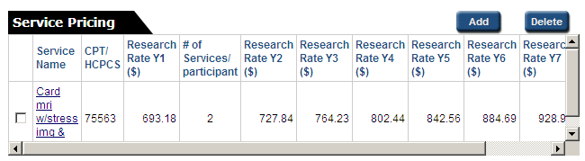
Figure: Service added to table
Information about the Research Rates:
The Research Rate Y1 is the amount owed to Allina for the year the study is approved (Y1).
Research Rate Y2-Y7 is the amount owed to Allina for each consecutive calendar year after the year of study approval. Using the example above, if the MRI test was approved in July 2009 the Y1 price is 693.00 and is effective from July 2009 through December 2009. The price starting January 1, 2010 is $728.00 through December 2010.
See SPA’s Scheduling, Registration & Billing Guide for more information on the billing and payment of services paid for by the study.
All research prices are subject to a yearly inflation factor (found at the bottom of Service & Pricing page). The inflation factor will remain the same for the services identified at the time the study is approved. Any services approved in a later year will be subject to the inflation factor of the current year.
Figure: Research Inflaction Factor 2009
Note:
- To add additional services required by the study, repeat Steps 1 – 6 for each service.
- To delete a service, check the box next to the service you want to delete and click Delete.
- Click on “Test Name” link to view/edit the record.

Other Services

Use this table for all services that cannot be found in the Service Pricing List (e.g, room charges).

Note: Please contact SPA if you have questions about services and we can help work through the details of particular services and study requirements. Once we have determined the appropriate services to be paid by the study, those services may be entered in eProtocol.

To enter services into the Other Services Table:
Step 1 - Click Add. Add Other Service pop-up is displayed.
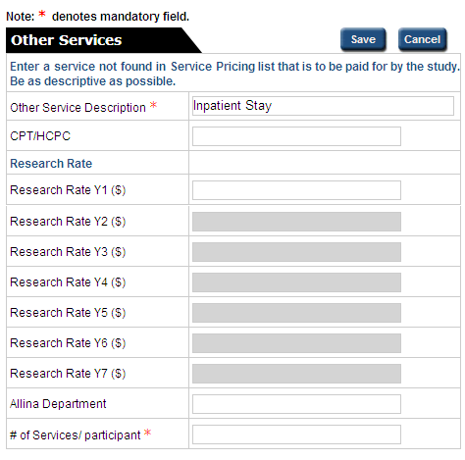
Figure: Add Other Services pop-up

Step 2 – Enter ‘Other Service Description’ (required).

- Be as descriptive as possible when entering an ‘Other Service Description’. The field for entry expands for additional text to be entered.

Step 3 – Enter ‘# of Services/participant’ (required).

- The total number of times each participant will receive the service indicated per study protocol or how many days a participant will stay in the facility. If the service is an inpatient stay, indicate the total number of days the participant will be in the facility because of the study. This area is only for services paid by the study. Routine care (billable) services are not listed in this area. They are covered as part of the Schedule of Events attached separately.

Step 4 (Optional) – Enter CPT/HCPC if known

Step 5 – Click Save. The pop-up will close and the record will be added to the Other Services table.

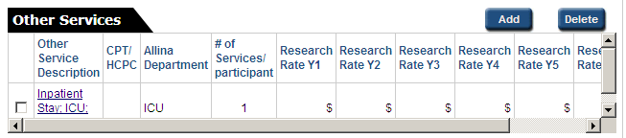

SPA will price the service after SPA Form is submitted.

Note:
- To add additional services required by the study, repeat Steps 1 – 6 for each service.
- To delete a service, check the box next to the service you want to delete and click Delete.
- Click on “Test Name” link to view/edit the record.

Pro Fee Services

This section will be completed by the SPA if professional services may be billed by Allina for any of the services listed in ‘Service Pricing’ or ‘Other Services’ table. Professional services may be billed by Allina even if they are not listed, but are still payable.

In most cases, professional services are billed by non-Allina owned practice groups and it is the responsibility of the research site to contact any other professional services groups. These include services for radiology, anesthesia, and pathology.

Optional: If you are aware of a professional service that may be billed by Allina, you may enter them here. The steps are similar to the Other Services table entry instructions.

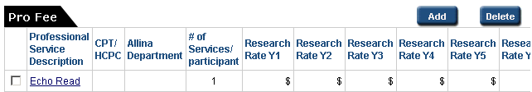

Figure: Echo Read in Pro Fee Pricing Table

Section 6 – Attachments
Attach required and other important documents related to the study you are submitting. You can see more about the types of attachments at the end of this section.
For studies linked to IRB Protocol, some of the SPA required attachments will copy from the IRB Protocol. Add any additional required attachments for SPA.
Required documents for all SPA studies include:
- PI Assurance/Affirmation
- Consent Form
Follow the steps given below to attach documents.
Step 1 - Click Add. The add Attachment pop-up is displayed.
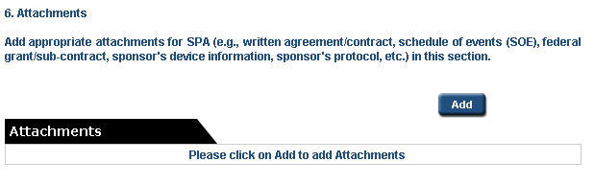
Step 2 - Select the Document Type from the drop down menu.
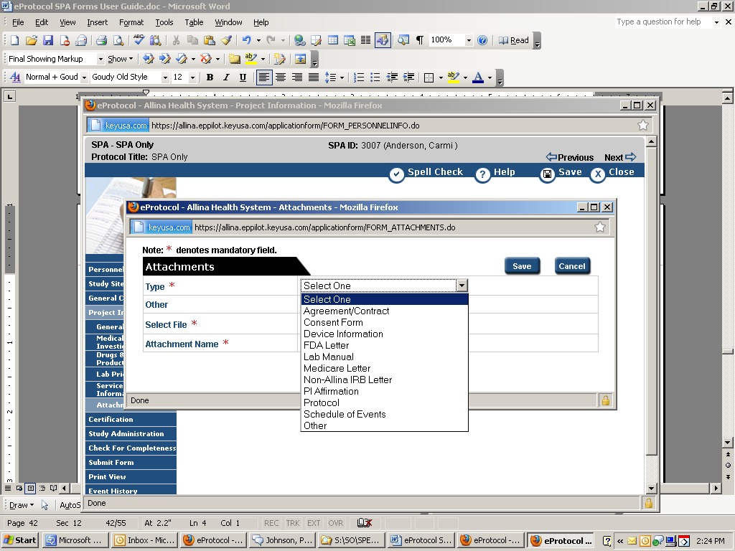

Step 3 – Click Browse... to select a saved document to be attached.
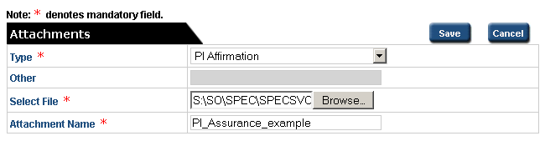
The name of the document is automatically added in ‘Attachment Name’ field. The name of the document can be changed here if needed.
Step 4 - Click Save. The attachments pop-up closes and the attachment is added to the SPA Form.
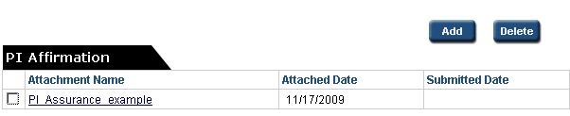
Note:
- Click the link under Attachment Name to view the attachment.
- To delete an attachment, select the checkbox by the record, and click Delete.
Attachment Types & Requirements:
- Agreement/Contract – Includes agreements or contracts of which Allina is a party. Includes Allina Purchased Service Agreement (PSA) and/or Vendor Service Agreement (VSA) if applicable. SPA will attach the final, signed agreements here.
- Consent Form –Required attachment for all SPA submissions. These may copy into SPA Form from IRB Form if linked to IRB protocol.
- Device Information –Required for studies involving Research Medical Devices. Includes any information on the research device from the sponsor. Information may include: manufacturing model or product numbers, device sizes, price lists, reimbursement information, etc.
- FDA Letter – Required for medical device projects involving an Investigation Device Exemption (IDE) device. The FDA letter must include the CMS Category (A or B) and that it is approved for use in the clinical trial. If the study involves a Category B medical device, which requires submission to Medicare Contractors, please be aware the Medicare Contractors will not approve a project if there are redacted sections on the FDA Letter. If you have questions about this section, please contact SPA.
- Lab Manual – If study requires lab services to be performed by the Allina Lab, attach any information specific to the required lab tests for Allina Lab reference. A study lab manual or specific lab sections from the protocol may be applicable.
- Medicare Letter –Any documentation that may have been received from a Medicare Contractor. SPA will attach any letters it receives under this description as well.
- Non-Allina IRB letter – Required for studies approved by a non-Allina IRB
- PI Affirmation/Assurance – Required for all submissions to SPA. This document will copy into SPA Form from IRB Form if linked to IRB protocol.
- Protocol – May be requested by SPA under certain circumstances, however SPA does not require the protocol to be attached. If a project is submitted to the Allina IRB, SPA has access to it there.
- Schedule of Events – Required for studies that will result in the billing of any services to third party payers. The Schedule of Events (SOE) documents the Principal Investigator’s determination of routine care and protocol induced costs for the study. Allina’s Research Compliance Program requires this document in order to support Allina’s billing to third party payer(s) or for audit/monitoring purposes. For more information on how to create a SOE, refer to Allina’s Research Billing Guide.
- Other – All other documents that may help support or provide explanation for the project information provided.

Certification
In this section, the obligation to upload the Principal Investigator Affirmation (Assurance) is outlined.
Check the box next to “The Principal Investigator has signed the Principal Investigator Affirmation, which has been uploaded into the eProtocol System.”
- The Principal Investigator (PI) Assurance Statement has all of the obligations of the PI related to the submission of the study to IRB and/or SPA.

- The PI must sign and agree to the Assurance Statement for each study in order to complete the SPA Form submission process.

- The eProtocol Study Idenfitication Number must be entered on the Assurance Statement before upload.
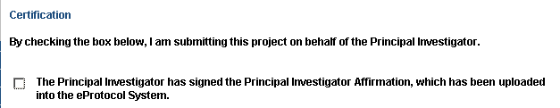
Figure: SPA Certification section

Study Administration
This section does not require completion by the researcher. It is availabe in View mode only and is completed, if applicable, by SPA after form submission.
SPA uses this section to record and report on the following administrative items:
- SPA Fee –Required for device studies where device set-up is required in Allina’s system
- Study Billing Requirements – Allina participant billing coding information; checked if applicable to the study
- Conditions of Approval – If a participant enrollment cap is set by SPA (only set for high cost/high-risk studies) it is entered here.
- Device Study Approval Record – Applicable to Investigational Device Exemption (IDE) studies where Medicare approval is required for participant billing. The approval decision and date of decision is recorded here.

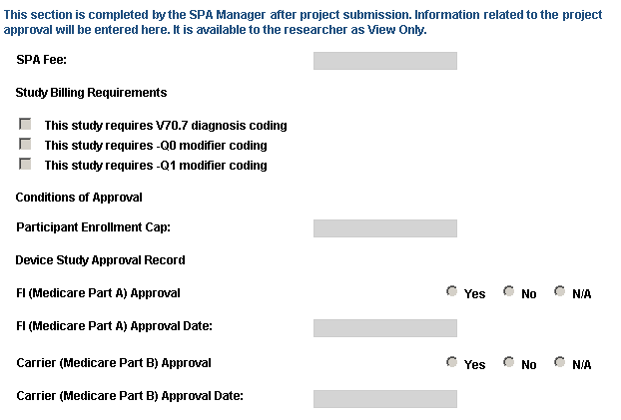
Figure: SPA Study Administration section

Check for Completeness
Before you submit the protocol, click the Check for Completeness link in the left navigation panel.
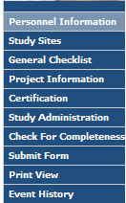
A pop-up will display a list of the sections that are incomplete. By clicking an item in the Resolution column, you will be transferred to the eProtocol page for the section in question.
Find the item described in the Resolution column (the link does not go to the specific item that is missing). All items in the Check for Completeness must be resolved before SPA Form can be submitted.
To return to the Check for Completeness, click the link in the left navigation panel. The system will check the protocol and refresh the list of incomplete sections.

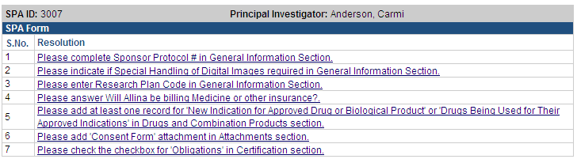
Figure: Check for Completeness

Submit Form
To submit the form to SPA for review, click on ‘Submit Form’ in the left navigation panel.
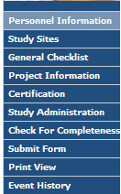

The confirmation pop-up will display.
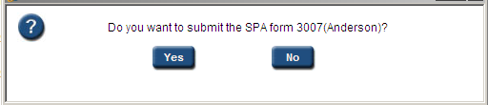
Figure: Submit Form - Confirmation pop-up
Click Yes to submit the form. If there are any missing details, the ‘Check for Completeness’ pop-up is displayed again.

Print View
To print the Protocol Application Form, click the Print View in the left navigation panel.
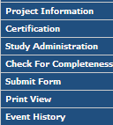
The Print View Decision pop-up is displayed.
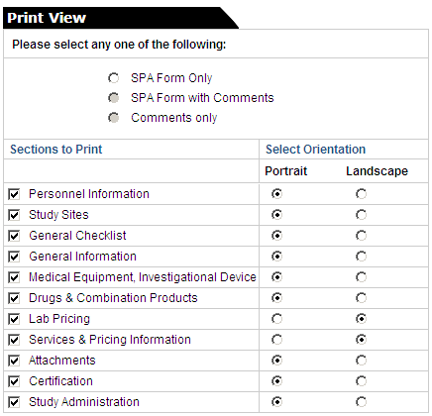
1
2
Step 1
Select the option—Protocol Only, Protocol with Comments, or Comments only—for the item(s) you wish to print. (“Comments” refers to SPA’s comments about your study. There will be no Comments if the protocol has not yet been submitted to SPA.)
Step 2
By default, all sections are selected. Un-select the options for the sections you do not wish to print by checking the appropriate checkboxes.
The page orientation is set to “Portrait” for all sections except ‘Lab Pricing’ and ‘Services and Pricing Information’ which are set to “Landscape”. You may change the orientation for any of the pages.
Step 3
Click OK at the bottom of the window. An Adobe .PDF file will be created and opened. You may save it to your computer by clicking File, then Save As in the upper left-hand corner of the window.

Event History
To view the history of the SPA Form, click Event History in left navigation panel.
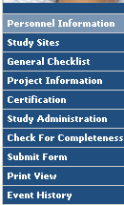
This section provides a summary of the major events over the form’s history: the Date of the event and the event action. Event action may include: form creation, form submission, form return, and SPA review or approval
View Attachments – click on the link provided to view the form attachments on the event history date.
Letters – SPA Approval (or non-Approval) letter may be accessed by clicking the letter link provided.
Email History – A history of autogenerated e-mails from the SPA system 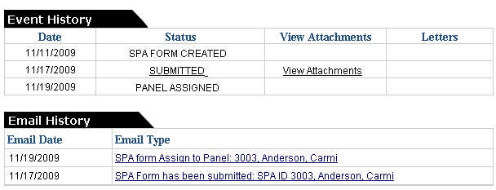
Figure: Event History

Return Notes
After your protocol has been submitted, SPA will conduct an initial review of the form and it’s content before for accepting for full review.
If more information or documentation is required, SPA will return the form to you. This action re-releases the protocol back to the investigator(s) with full EDIT capability so that any requested changes can be made. If a protocol is returned, you will receive a system e-mail notification of the return.
To review and edit to the returned SPA Form, complete the steps below.
Step 1
The Protocol Status that displays on your home page will change to "Resubmit the SPA Form."

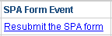

Step 2

Open the protocol with Edit access by clicking on either the SPA ID or SPA Form Event link: Resubmit the SPA Form.

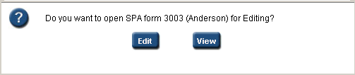

Step 3

Click the button in the left-hand menu labeled Return Notes as shown in example below.
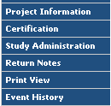

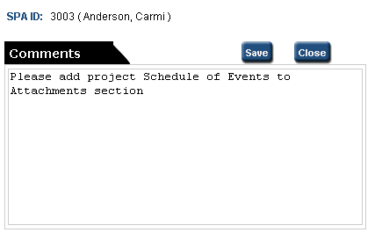
Figure: Return Notes pop-up
Step 4
Enter the appropriate section(s) of the form and complete the required changes.
Step 5
When you are ready to resubmit the protocol, simply click the Submit Form button just as you did for the initial submission.


